New Offerings from Moksha!

One silver lining from COVID has been the opportunity to learn
new avenues of healing that I am really excited to share!

I had the good fortune to study somatic trauma healing with Stephen Terrell and I have been practicing Transforming Touch & Transforming Intentional Touch for over 2 years now. I often blend this work with Polarity and Reiki. I continue to study with Stephen whenever possible. (See flyer and website for more information)

I also have been studying Sound Healing with numerous healers in this field and I am weaving this powerful and effective work into my sessions as well as using it in my own life to clear, balance, ground and heal myself. Sound healing has been a part of my life for many years and I am excited to bring this work more into my sessions and classes.

I have also been inspired to offer a new class called Polarity Therapy Daily Balancing Protocol.
I have been using this work on myself daily for about 5 years. The protocol can also be used with clients as a general balancing session. It is a short class, only 5 hours, and anyone interested is welcome. Now that COVID is waning, (keeping my fingers crossed!!) I hope to be offering more classes again.

I also offer private classes, with one to four participants, as continuing education for massage therapists, or other interested folks. You can find a list of NCBTMB approved courses on my website. Let me know if you would like to plan a class.

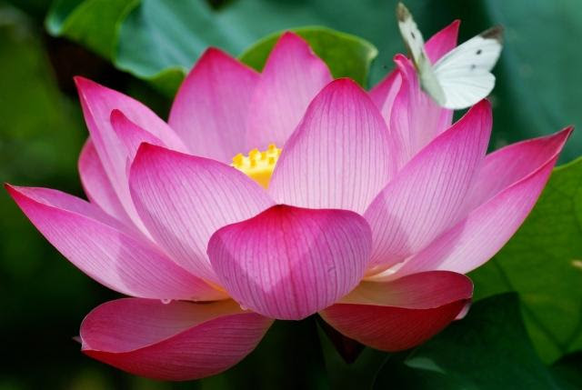

I would love to share this work with you! For $20 off first TT appointment-mention this notice.
Please be in touch if you want to learn more, schedule a session or a class.
919-384-5406
mokshakolman@gmail.com
www.lotusblossomwellness.com

