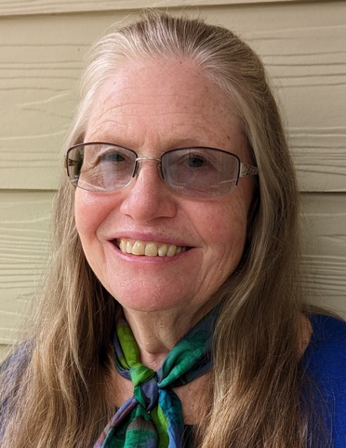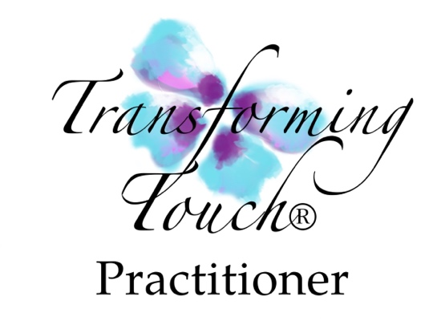
For information & appointments call
Moksha Sharon Kolman
  - LMBT#204 Reiki Master Board Certified Polarity Practitioner
919-384-5406
and visit
www.lotusblossomwellness.com
mokshakolman@gmail.com

MOKSHA SHARON KOLMAN
  - Somatic Trauma Healing
Moksha Kolman is a certified Transforming Touch®
and Transforming Intentional Touch® practitioner.

Transforming Touch® assists individuals to have greater ease and balance in everyday life by regulating the nervous system and bringing safety back to the body. Often times when we are young, our caretakers aren't able to fully connect and support our early development due to medical or psychological reasons. This work helps repair those early ruptures through building somatic trust and attachment so that one has more choice and experiences more joy in life. We work very slowly over a period of time so as to minimize re-traumatization and allow for integration. Safety and trust within the therapeutic relationship is the cornerstone for this powerful healing work.
My teacher, Stephen Terrell, developer of Transforming Touch and co-author of “Nurturing Resilience” describes this work as a protocol-based healing modality that supports the body to better health through the nervous system. In-person and virtual sessions are available.
With Transforming Intentional Touch® we schedule a time when we can connect in a safe private setting via zoom or another video platform.

Additional Healing Therapies

Moksha offers healing sessions in Polarity Therapy, Reiki Natural Healing, Sound Healing and other energy modalities, often combining two or more methods. Distant Healing sessions can be done at a prearranged time when the person receiving is in a relaxed and safe place, preferably lying down. In person sessions are offered at Moksha’s home office.

Lotus Blossom Wellness
Moksha has taught and practiced in the healing arts since 1984.

FEES:
90 minutes $130 60 minutes $90
75 minutes $110 45 minutes $75

